## WHAT IS IT?

This project explores the evolutionary significance of territoriality in social insects as a potential form of collective defense against infectious diseases. We used an agent-based simulation modeling approach to test whether the monopolization of space for resource foraging could efficiently neutralize the spread of a novel infection among established colonies of social insects. Our analyses help clarify the conditions under which territorial behaviors might confer an evolutionary advantage in a population or species under threat from pathogens.

## HOW IT WORKS

We have modified the Netlogo Ant foraging simulation (Wilensky, 1997) to study how territorial behaviors can affect the spread of infections among a pair of neighboring colonies. A key parameter of the model is the population’s effectiveness at maintaining its territorial boundary. To simplify this model, we assume that ant colony territories are maintained by recognition and avoidance behavior of conspecifics (nestmates) and heterospecifics (non-nestmates). In other words, we assume that each ant can recognize its own colony’s territory and avoids entering territory of neighboring colonies. The dimensions of the controllable region (i.e., territory) are the same for both colonies.

## HOW TO USE IT

Run on Netlogo version 6.1

Click the SETUP button to set up the ant nests (in violet and yellow, at the top left and bottom right corners of the arena) and three piles of food (in green, at the center). Click the GO button to start the simulation.

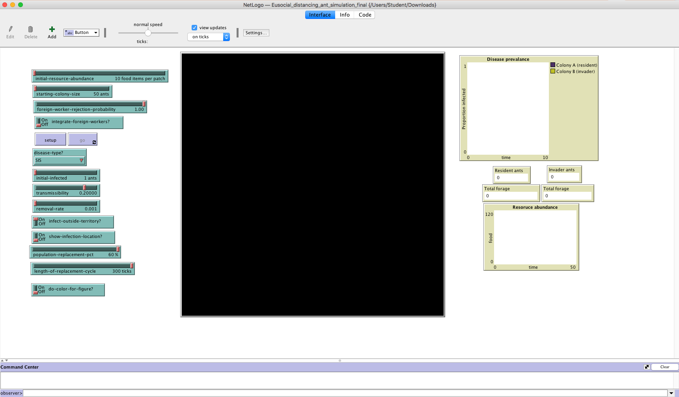

The details for the BEHAVIORSPACE simulation experiments are in the appendix of the paper (Lemanski et al. 2021).

Below are screenshots of the settings.

